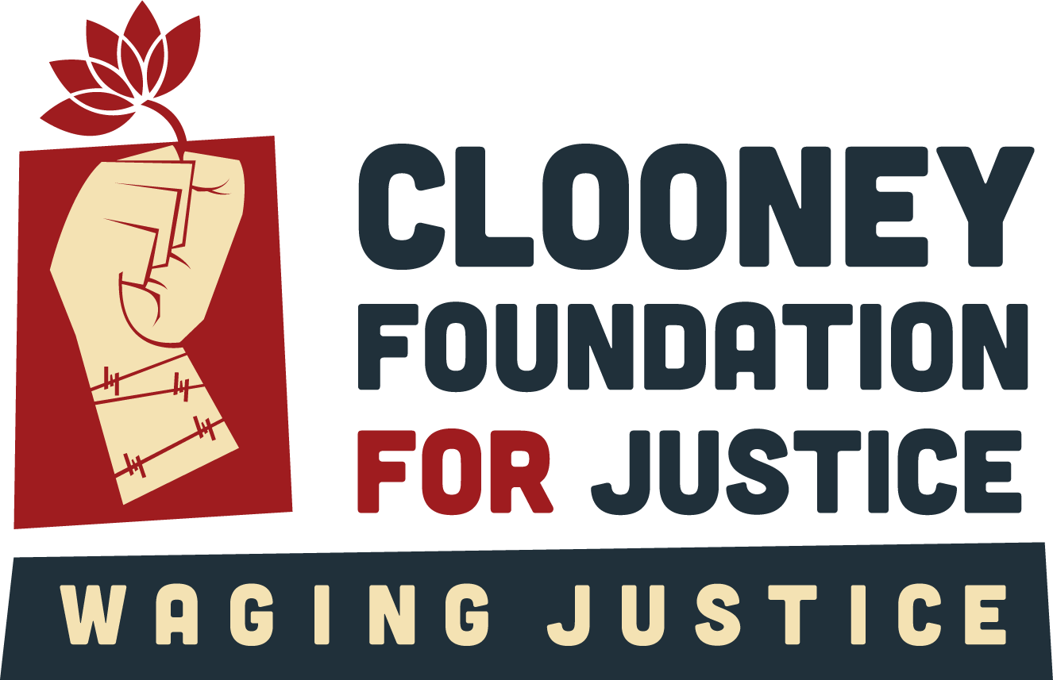

Media and Communications Intern
Position Description

Job Summary

This is a three-month internship with a time commitment of 15 hours a week. The successful candidate will be paid £12/hour for the duration of the contract.

The Clooney Foundation for Justice (CFJ), an international non-governmental organization (NGO) that advocates for justice through accountability for human rights abuses around the world, seeks a Media and Communications Intern. We are looking for someone with an interest in using communications, storytelling, and creative campaigning to create impact. A working knowledge of both traditional and new media is important, but you will also be given space to learn and grow while working here. An interest in international human rights and justice is essential for the incoming intern to get the most out of this role.

The ideal candidate will be creative, self-motivated, and able to work effectively against deadlines. The Intern will help create content for and grow our social media channels and help support media and communications efforts on behalf of CFJ generally as well as each of our flagship initiatives – TrialWatch, The Docket, and Waging Justice for Women.

Roles and Responsibilities

Reporting to the Head of Digital Communications and working in close coordination with the Director of Communications and Media and the Communications Associate, the Intern will:

- Research relevant media and build press lists ahead of report launches
- Maintain the publications and events calendar
- Plan social media campaigns around relevant international and UN days, such as World Press Freedom Day
- Source photographs and b-roll for creative projects
- Organize and subtitle footage for CFJ’s upcoming video projects
- Design social media and website assets for reports and projects
- Help build strategy to grow CFJ’s social media audience
- Proofread statements, donor materials, and other documents as needed
- Help update and maintain cfj.org
- Keep our trial map up to date
- Monitor and analyze media coverage
- Expand and maintain CFJ’s style guide
- Take meeting minutes, implement action plans, and ensure follow-up
- Other duties as require

Skills and Qualifications

Required:

- Proven interest in media and communications as a tool for global change
- Proven interest in human rights and international justice
- Excellent written and spoken English
- Self-motivated and able to work remotely with limited supervision
- Attention to detail
- Confidence to ask questions when unclear and feeling comfortable communicating workload and capacity

Preferred:

- Experience using social media in a professional capacity
- Experience using Canva or similar tools to make social media assets
- Proof reading experience
- Fluency in a second language, particularly Spanish, Ukrainian, Russian, Arabic, or Thai, would be an asset but is not essential
- Experience working with translators
- Experience transcribing and subtitling video files

Location
Sheffield, UK

Compensation
£12/hour

Start Date
As soon as possible

To Apply

Submit a CV and no more than 200 words explaining the reasons for your interest in this internship to your university coordinator. Please include your daily availability.

CFJ is committed to diversity in its workforce and is an equal opportunity employer. We actively seek a diverse applicant pool and encourage candidates of all backgrounds to apply. We do not discriminate on the basis of race, religious beliefs, color, national origin, gender identity, sexual orientation, age, marital status, veteran status, or disability.

